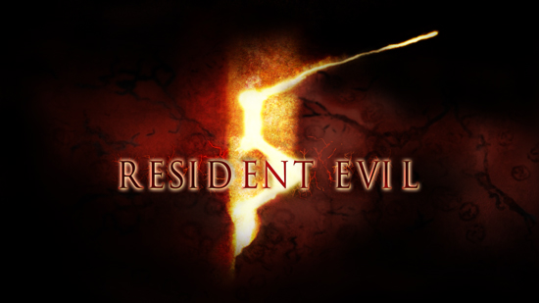
Release Date: March 13, 2009
Genre: Survival Horror
Platform: PS3, Xbox 360
Rating: TBC
Developer: Capcom®
Price: TBC


The biohazard threat has not ended: Just when it seemed that the menace of Resident Evil had been destroyed, along comes a new terror to send shivers down player’s spines. Chris Redfield, returning Resident Evil hero, has followed the path of the evil literally around the globe. After joining a new organization, Chris heads to Africa where the latest bioterrorism threat is literally transforming the people and animals of the city into mindless, maddened creatures. He is joined by a new partner, Sheva Alomar, who lends her strength, intelligence and sharp-shooting skills to the mission. In order to survive, Chris and Sheva must work together to take on the challenges of discovering the truth behind this evil plot. Utilising a revolutionary new co-op mode of gameplay, players will be able to assume control of either Chris or Sheva and experience Resident Evil in new ways. In Resident Evil 5, Capcom will have players fearing the daylight as much as they have feared shadow in previous games.
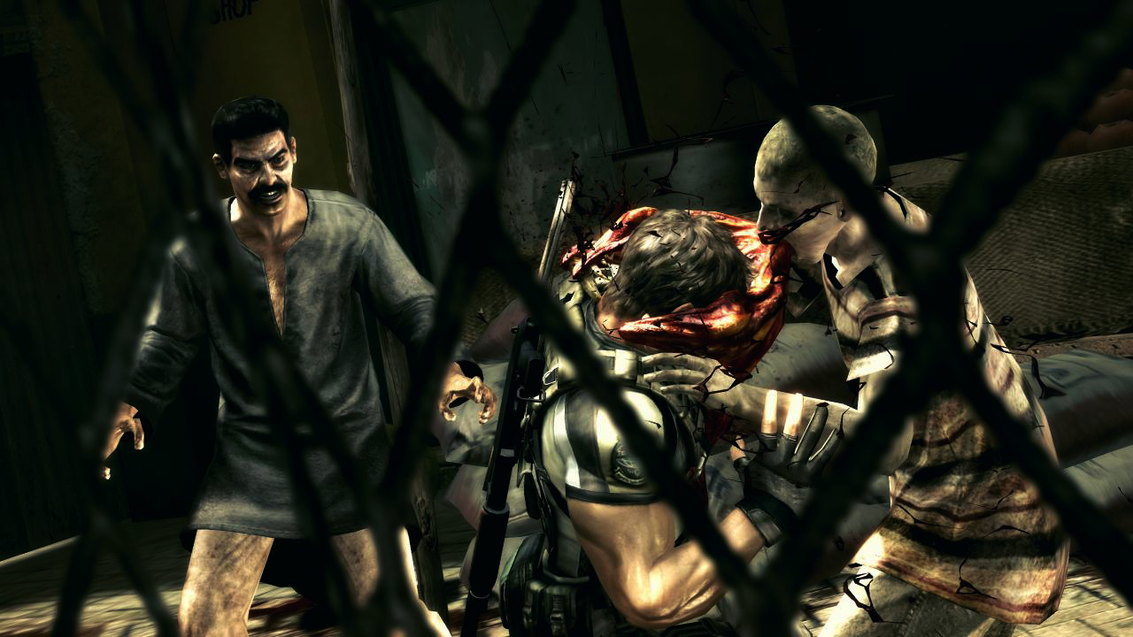
Co-producers and series veterans Jun Takeuchi (Lost Planet) and Masachicka Kawata (Resident Evil 4 Wii Edition, Resident Evil: The Umbrella Chronicles) unleash an unprecedented level of fear for the next generation in Resident Evil 5, the sequel to one of the highest-rated videogames in history, according to Metacritic.com and Gamerankings.com. Promising to revolutionise the series by delivering an unbelievable level of detail, realism and control, Resident Evil 5 is certain to bring new fans to the series. New technology developed specifically for the game, as well as incredible changes to both the gameplay and world of Resident Evil will make this a must-have game for gamers across the globe.

The Resident Evil series has sold over 34 million units since the original game was released in 1996 and has spawned a multi-million dollar trilogy of films from Sony Pictures. Resident Evil 5 will revolutionise the Resident Evil series, just as Resident Evil 4 did.

Features
- Chris Redfield, protagonist of the original Resident Evil and Resident Evil: Code Veronica, returns
- Chris is joined by new character Sheva Alomar, an African special agent tasked with investigating the epidemic
- 2 player co-op online gameplay means that players are not alone in their fight against the horror lurking around every corner
- Simultaneous Pan Western release date for both PlayStation 3 and Xbox 360 on March 13, 2009
- New enemies bring new challenges: speed and intelligence make adversaries as dangerous singly as they are in groups.
- An arsenal of weapons at the player’s command to keep the evil at bay, including knives, pistols, machine guns, sniper rifles and more.
- Lighting effects provide a new level of suspense in both harsh light and deepest shadow
- True high definition gaming on multiple game platforms, using an advanced version of Capcom’s proprietary game engine, MT Framework, which powered the next-gen, million-plus hit titles Devil May Cry 4, Lost Planet and Dead Rising.

